# Check the versions of libraries

# Python version

import sys

print('Python: {}'.format(sys.version))

# scipy

import scipy

print('scipy: {}'.format(scipy.__version__))

# numpy

import numpy

print('numpy: {}'.format(numpy.__version__))

# matplotlib

import matplotlib

print('matplotlib: {}'.format(matplotlib.__version__))

# pandas

import pandas

print('pandas: {}'.format(pandas.__version__))

# scikit-learn

import sklearn

print('sklearn: {}'.format(sklearn.__version__))

# Load libraries

import pandas as pd

#from pandas.t

dataset = pd.read_csv('C:\\Users\\vartika\\Desktop\\bankr2.csv')

print(dataset.shape)

#head

print(dataset.head(20))

#statistical summary

print(dataset.describe())

print(dataset.groupby('y').size())

import matplotlib.pyplot as plt

#data visualization

#univariate plots

#box and whisker plots

dataset.plot(kind='box', subplots=True, layout=(10,10), sharex=False, sharey=False)

plt.show()

#histograms

dataset.hist()

plt.show()

#scatter plot matrix

#scatter_matrix(dataset)

#plt.show()

from sklearn import model_selection

from sklearn.model_selection import KFold

#create a validation dataset

# split-out validation dataset

array = dataset.values

X = array[:,0:3]

X=X.astype('int')

Y = array[:,3]

Y=Y.astype('int')

validation_size = 0.20

seed = 7

X_train, X_validation, Y_train, Y_validation = model_selection.train_test_split(X, Y, test_size=validation_size, random_state=seed)

print(X_train.shape, Y_train.shape)

print(X_validation.shape, Y_validation.shape)

from pandas.plotting import scatter_matrix

import matplotlib.pyplot as plt

from sklearn import model_selection

from sklearn.metrics import classification_report

from sklearn.metrics import confusion_matrix

from sklearn.metrics import accuracy_score

from sklearn.linear_model import LogisticRegression

from sklearn.tree import DecisionTreeClassifier

from sklearn.neighbors import KNeighborsClassifier

from sklearn.discriminant_analysis import LinearDiscriminantAnalysis

from sklearn.naive_bayes import GaussianNB

from sklearn.svm import SVC

# Test options and evaluation metr

num_folds = 10

num_instances = len(X_train)

seed = 7

scoring = 'accuracy'

# Spot Check Algorithms

models = []

models.append(('LR', LogisticRegression()))

models.append(('LDA', LinearDiscriminantAnalysis()))

models.append(('KNN', KNeighborsClassifier()))

models.append(('DT', DecisionTreeClassifier()))

models.append(('NB', GaussianNB()))

models.append(('SVM', SVC()))

# evaluate each model in turn

results = []

names = []

for name, model in models:

kfold = model_selection.KFold(n_splits=10, random_state=seed)

cv_results = model_selection.cross_val_score(model, X_train, Y_train, cv=kfold, scoring=scoring)

results.append(cv_results)

names.append(name)

msg = "%s: %f (%f)" % (name, cv_results.mean(), cv_results.std())

print(msg)

# Compare Algorithms

fig = plt.figure()

fig.suptitle('Algorithm Comparison')

ax = fig.add_subplot(111)

plt.boxplot(results)

ax.set_xticklabels(names)

plt.show()

# Make predictions on validation dataset

knn = KNeighborsClassifier()

knn.fit(X_train, Y_train)

predictions = knn.predict(X_validation)

print('Accuracy score knn',accuracy_score(Y_validation, predictions))

print(confusion_matrix(Y_validation, predictions))

print(classification_report(Y_validation, predictions))

#prediction of logistic regression

model=LogisticRegression(penalty='l2', max_iter=1000)

model.fit(X_train, Y_train)

predictions=model.predict(X_validation)

print('Accuracy score LR',accuracy_score(Y_validation, predictions))

print(confusion_matrix(Y_validation, predictions))

print(classification_report(Y_validation, predictions))

#prediction of svm

svm = SVC()

print('SVM')

svm.fit(X_train, Y_train)

predictions=svm.predict(X_validation)

print('Accuracy score SVM',accuracy_score(Y_validation, predictions))

print(confusion_matrix(Y_validation, predictions))

print(classification_report(Y_validation, predictions))

#prediction of decision tree

dt=DecisionTreeClassifier()

dt.fit(X_train, Y_train)

predictions = dt.predict(X_validation)

print('Accuracy score DT',accuracy_score(Y_validation, predictions))

print(confusion_matrix(Y_validation, predictions))

print(classification_report(Y_validation, predictions))

#prediction of gaussian nb

nb=GaussianNB()

nb.fit(X_train, Y_train)

predictions = nb.predict(X_validation)

print('Accuracy score NB',accuracy_score(Y_validation, predictions))

print(confusion_matrix(Y_validation, predictions))

print(classification_report(Y_validation, predictions))

#prediction of LDA

lda=LinearDiscriminantAnalysis()

lda.fit(X_train, Y_train)

predictions = lda.predict(X_validation)

print('Accuracy score LDA',accuracy_score(Y_validation, predictions))

print(confusion_matrix(Y_validation, predictions))

print(classification_report(Y_validation, predictions))

# Check the versions of libraries

# Python version

import sys

print('Python: {}'.format(sys.version))

# scipy

import scipy

print('scipy: {}'.format(scipy.__version__))

# numpy

import numpy

print('numpy: {}'.format(numpy.__version__))

# matplotlib

import matplotlib

print('matplotlib: {}'.format(matplotlib.__version__))

# pandas

import pandas

print('pandas: {}'.format(pandas.__version__))

# scikit-learn

import sklearn

print('sklearn: {}'.format(sklearn.__version__))

# Load libraries

import pandas as pd

#from pandas.t

dataset = pd.read_csv('C:\\Users\\vartika\\Desktop\\bankr1.csv')

print(dataset.shape)

#head

print(dataset.head(20))

#statistical summary

print(dataset.describe())

print(dataset.groupby('y').size())

import matplotlib.pyplot as plt

#data visualization

#univariate plots

#box and whisker plots

dataset.plot(kind='box', subplots=True, layout=(10,10), sharex=False, sharey=False)

plt.show()

#histograms

dataset.hist()

plt.show()

#scatter plot matrix

#scatter_matrix(dataset)

#plt.show()

from sklearn import model_selection

from sklearn.model_selection import KFold

#create a validation dataset

# split-out validation dataset

array = dataset.values

X = array[:,0:3]

X=X.astype('int')

Y = array[:,3]

Y=Y.astype('int')

validation_size = 0.20

seed = 7

X_train, X_validation, Y_train, Y_validation = model_selection.train_test_split(X, Y, test_size=validation_size, random_state=seed)

print(X_train.shape, Y_train.shape)

print(X_validation.shape, Y_validation.shape)

from pandas.plotting import scatter_matrix

import matplotlib.pyplot as plt

from sklearn import model_selection

from sklearn.metrics import classification_report

from sklearn.metrics import confusion_matrix

from sklearn.metrics import accuracy_score

from sklearn.linear_model import LogisticRegression

from sklearn.tree import DecisionTreeClassifier

from sklearn.neighbors import KNeighborsClassifier

from sklearn.discriminant_analysis import LinearDiscriminantAnalysis

from sklearn.naive_bayes import GaussianNB

from sklearn.svm import SVC

# Test options and evaluation metr

num_folds = 10

num_instances = len(X_train)

seed = 7

scoring = 'accuracy'

# Spot Check Algorithms

models = []

models.append(('LR', LogisticRegression()))

models.append(('LDA', LinearDiscriminantAnalysis()))

models.append(('KNN', KNeighborsClassifier()))

models.append(('DT', DecisionTreeClassifier()))

models.append(('NB', GaussianNB()))

models.append(('SVM', SVC()))

# evaluate each model in turn

results = []

names = []

for name, model in models:

kfold = model_selection.KFold(n_splits=10, random_state=seed)

cv_results = model_selection.cross_val_score(model, X_train, Y_train, cv=kfold, scoring=scoring)

results.append(cv_results)

names.append(name)

msg = "%s: %f (%f)" % (name, cv_results.mean(), cv_results.std())

print(msg)

# Compare Algorithms

fig = plt.figure()

fig.suptitle('Algorithm Comparison')

ax = fig.add_subplot(111)

plt.boxplot(results)

ax.set_xticklabels(names)

plt.show()

# Make predictions on validation dataset

knn = KNeighborsClassifier()

knn.fit(X_train, Y_train)

predictions = knn.predict(X_validation)

print('Accuracy score knn',accuracy_score(Y_validation, predictions))

print(confusion_matrix(Y_validation, predictions))

print(classification_report(Y_validation, predictions))

#prediction of logistic regression

model=LogisticRegression(penalty='l2', max_iter=1000)

model.fit(X_train, Y_train)

predictions=model.predict(X_validation)

print('Accuracy score LR',accuracy_score(Y_validation, predictions))

print(confusion_matrix(Y_validation, predictions))

print(classification_report(Y_validation, predictions))

#prediction of svm

svm = SVC()

print('SVM')

svm.fit(X_train, Y_train)

predictions=svm.predict(X_validation)

print('Accuracy score SVM',accuracy_score(Y_validation, predictions))

print(confusion_matrix(Y_validation, predictions))

print(classification_report(Y_validation, predictions))

#prediction of decision tree

dt=DecisionTreeClassifier()

dt.fit(X_train, Y_train)

predictions = dt.predict(X_validation)

print('Accuracy score DT',accuracy_score(Y_validation, predictions))

print(confusion_matrix(Y_validation, predictions))

print(classification_report(Y_validation, predictions))

#prediction of gaussian nb

nb=GaussianNB()

nb.fit(X_train, Y_train)

predictions = nb.predict(X_validation)

print('Accuracy score NB',accuracy_score(Y_validation, predictions))

print(confusion_matrix(Y_validation, predictions))

print(classification_report(Y_validation, predictions))

#prediction of LDA

lda=LinearDiscriminantAnalysis()

lda.fit(X_train, Y_train)

predictions = lda.predict(X_validation)

print('Accuracy score LDA',accuracy_score(Y_validation, predictions))

print(confusion_matrix(Y_validation, predictions))

print(classification_report(Y_validation, predictions))

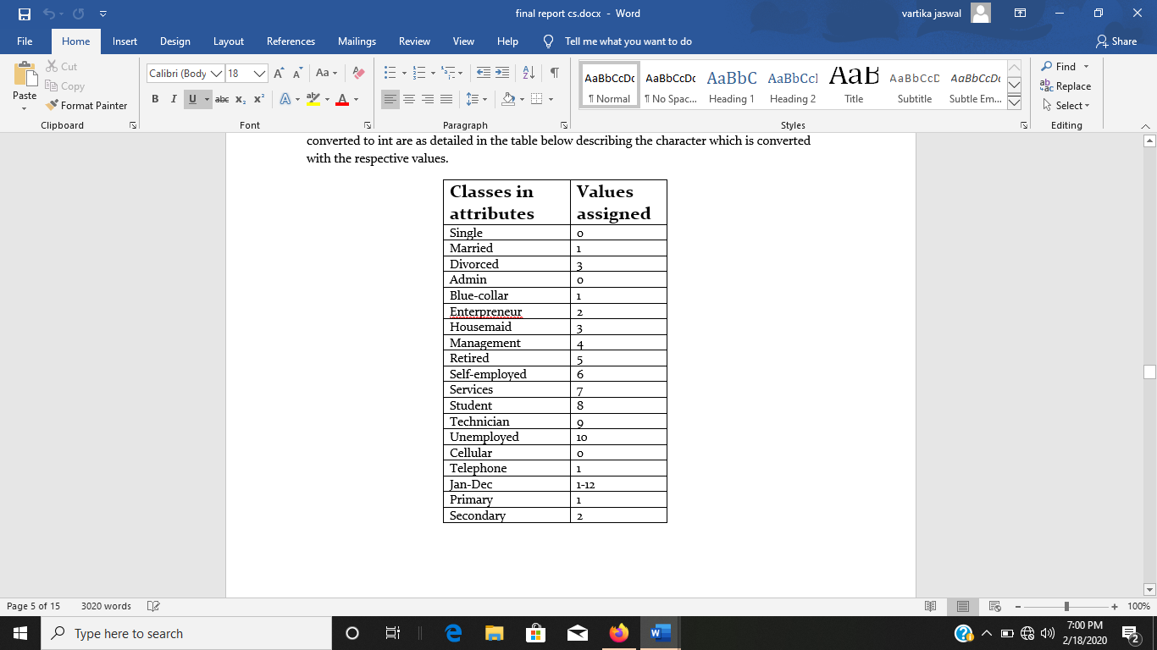changed values in bankr1 from the downloaded dataset